Can you make the changes to the rmarkdown pdf file

For problem 1:

(A) the graph does not form a linear pattern as it has a strong relationship it would be best suited to model it with a curve instead of a line

(B) this graph shows a strong relationship, linear model is not reasonable in this case and would be better to model it with a curve

(C) this graph depicts a slight weaker relationship and the application of a linear model is reasonable as it forms a perfect linear pattern

(D) the graph shows a weak relationship and you could fit a line thus linear model is reasonable

(E) this graph shows a moderate relationship it is reasonable to fit a linear model

(F) this graph shows a moderate linear relationship thus a linear model is reasonable

Please space out problem 2a and 2b as they are in one sentence so it’s confusing to read

Please fix problem 3

3(B): there is a weak positive linear relationship between husband’s and wives heights and they aren’t any outliers

3(C): the plot comparing husband and wive’s ages shows a stronger correlation

Problem 5

For 5(A): please show that for the equation is written like this correction should be made height= 106.23 + 0.61 x girth

5(B): a change in girth by 1cm increases height by 0.61cm and when shoulder girth is 0 the height is expected to be 106.23cm

5(C): 106.23 + 0.61 x 100

## [1] 167.23

5(D): 160 - 167.23

## [1] - 7.23

The residual means that the student was 7.23 shorter than predicted

Problem 6 (a) should looks like this on RMarkdown :

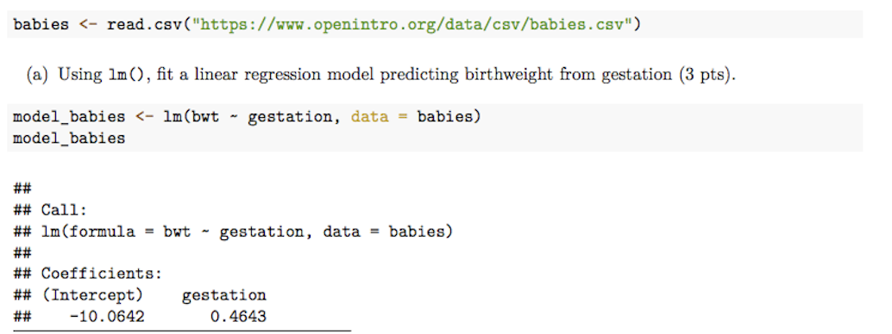

Problem 6(B) should be changed to :



